A report on

**ROAD ACCIDENT ASSISTANCE SYSTEM**

Submitted by

**Gone Sriram (20BCS090)**

**CSE, 2ND YEAR**



PDPM INDIAN INSTITUTE OF INFORMATION TECHNOLOGY, DESIGN AND

MANUFACTURING JABALPUR, INDIA

November 16th , 2021

**Introduction**

Every year the lives of approximately 1.3 million people are cut short as a result of a road traffic crash. Between 20 and 50 million more people suffer non-fatal injuries, with many incurring a disability as a result of their injury. Road traffic crashes cost most countries 3% of their gross domestic product.

So, basically the idea of “Road accident assistance system” is to store the details of accidents reported by the users , analyze and visualize the data and fetching details of any reported accident.

1. **Purpose & Scope**

This website will help to keep a record of road accidents and will help us to analyze data. Here user will enter details of accidents witnessed by him. This details will get stored. Users can report an accident by login their details or by registering themselves and also users can access the information provided by us of first aid .

1. **Admin and user functionality:**  
   ADMIN :   
    * Admin can add another admin.  
    * He can add, remove, delete, verify and unverify users.  
    * He can also access all registered users, hospitals, accident details.  
    * He can verify accidents and check details of verified/unverified accidents.  
     
   USER :  
    * User can login/register.  
    * He can report accident by filling accident details form.  
    * Verified users can search accident by hospital/victim name.  
    * Verified user can see all reported accidents and registered hospital details.

* He can use maps to find location and registered hospitals.

1. **Modules and their description :**   
    * User Login   
     
    * Admin Login  
     
    * Accident Detail form ( To store details of accident).  
     
    * Emergency Contact Numbers like, police station / hospital etc.  
     
    * First- aid template ( In case someone witnesses an accident and medical help can not reach immediately. This will contain everything about how to handle emergency situations till the medical help is not there.

*Searching accident related details.  
   
 * Map for registered hospitals.

1. **Technology Used**

* HTML : The structure of this webpage has been designed using HTML  
  
 * CSS : The design and animations are done using CSS  
  
 * JAVASCRIPT : JS has been used to add interactive behavior to the website  
  
 * PHP : PHP is being used as a server-side language  
  
 * MySQL : Website database is designed using MySQL  
  
 * BOOTSTRAP : This has been used to design the webpages and make them responsive

1. **Database Designing**
   1. Entity Relationship Diagram (ERD)

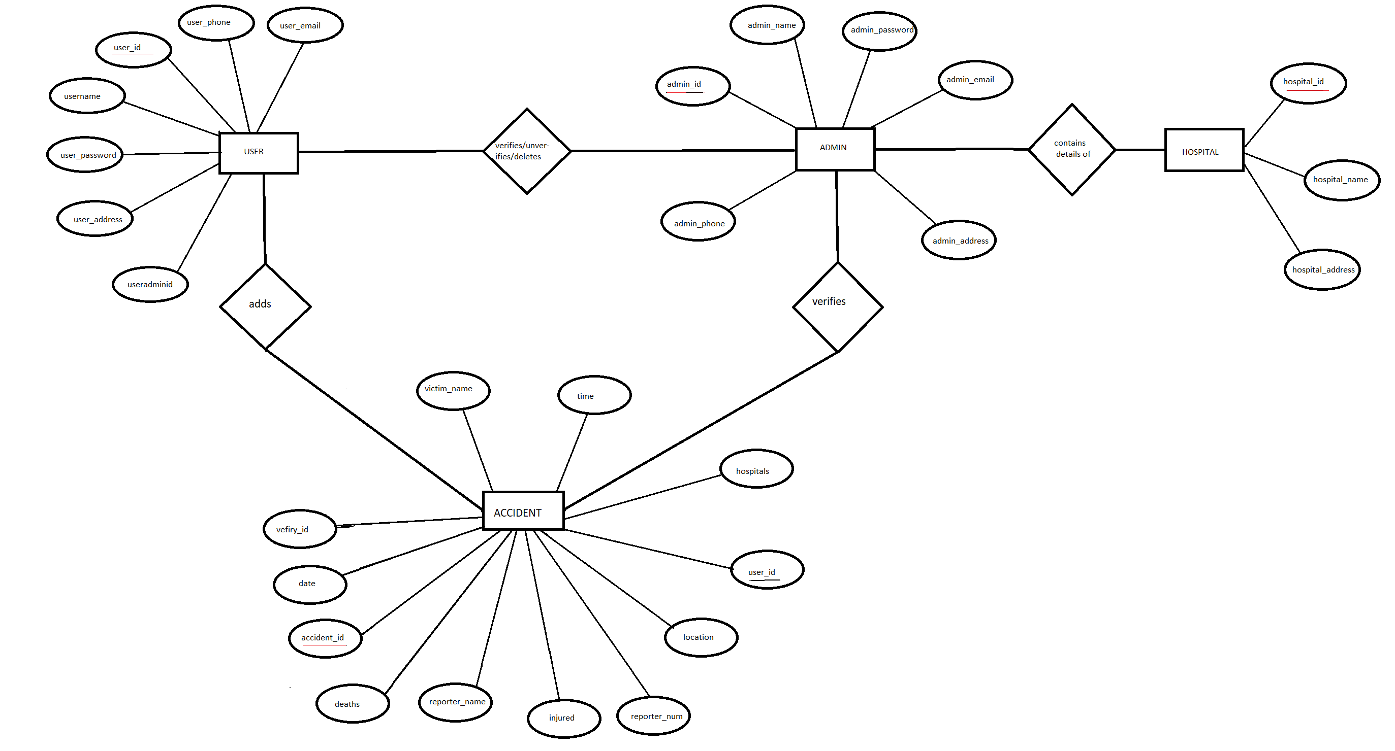

1. **Project Screenshots**

**Database screenshots-**

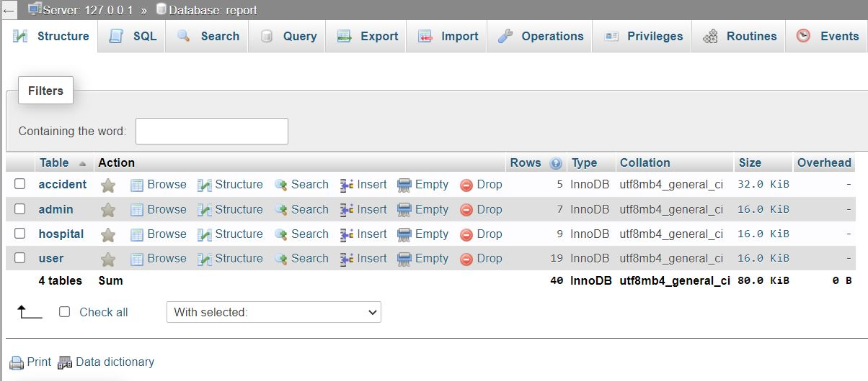

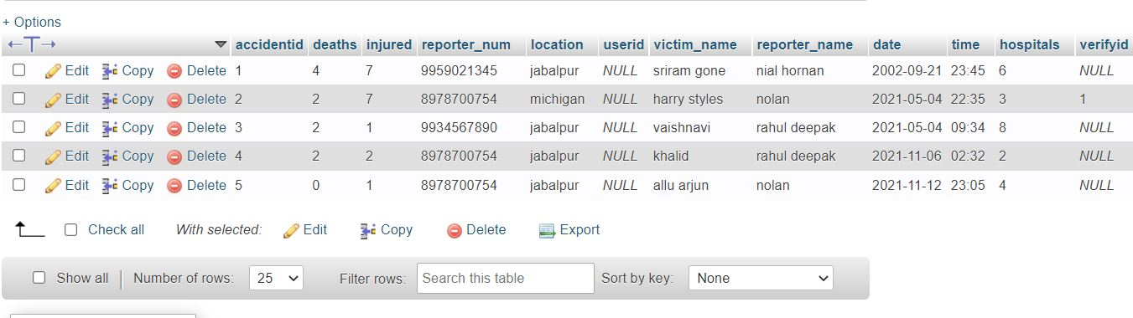

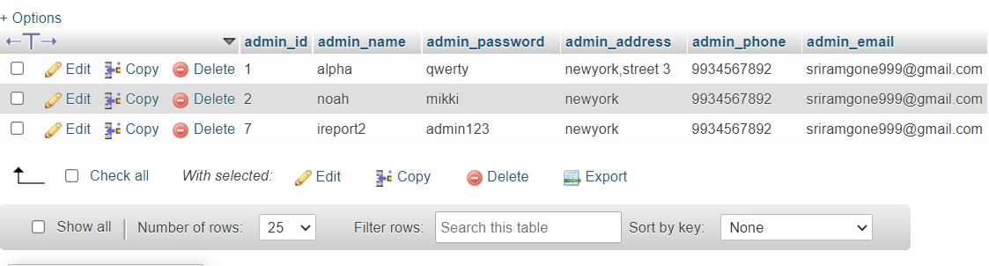

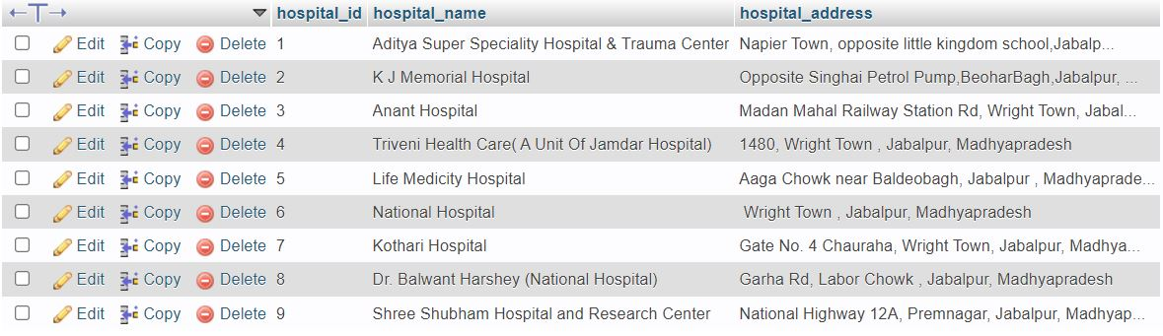

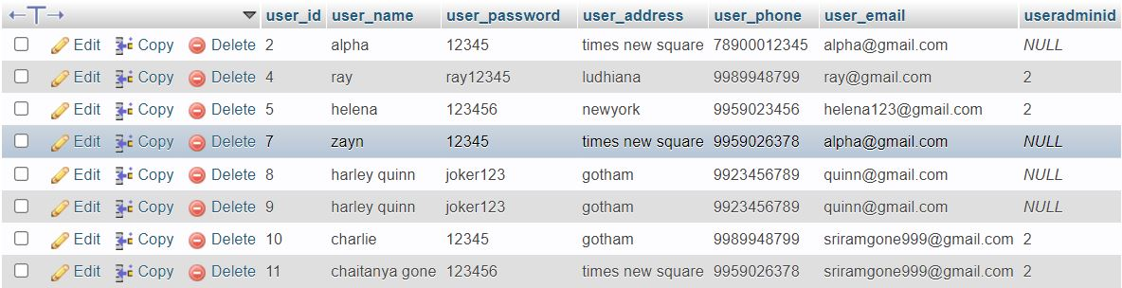

**Admin Dashboard-**

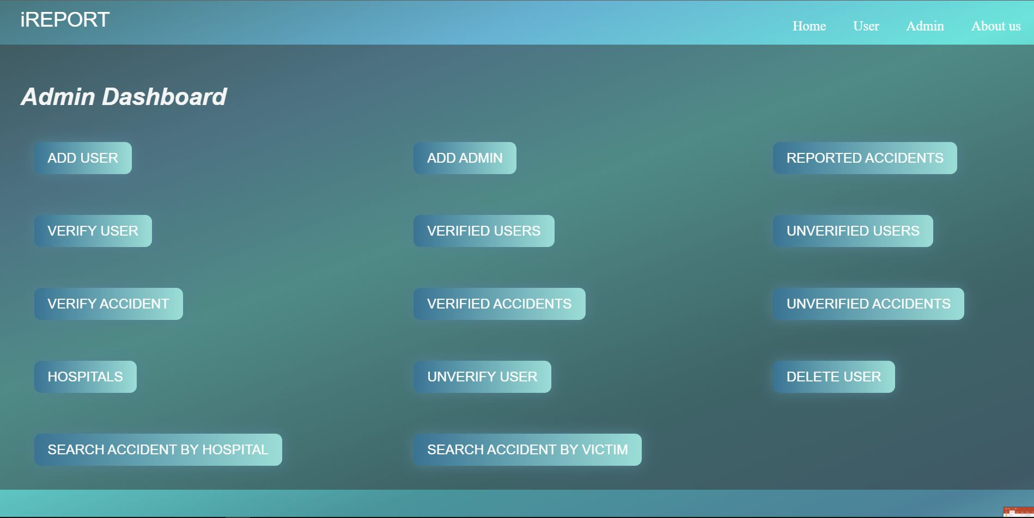

**Report form-**

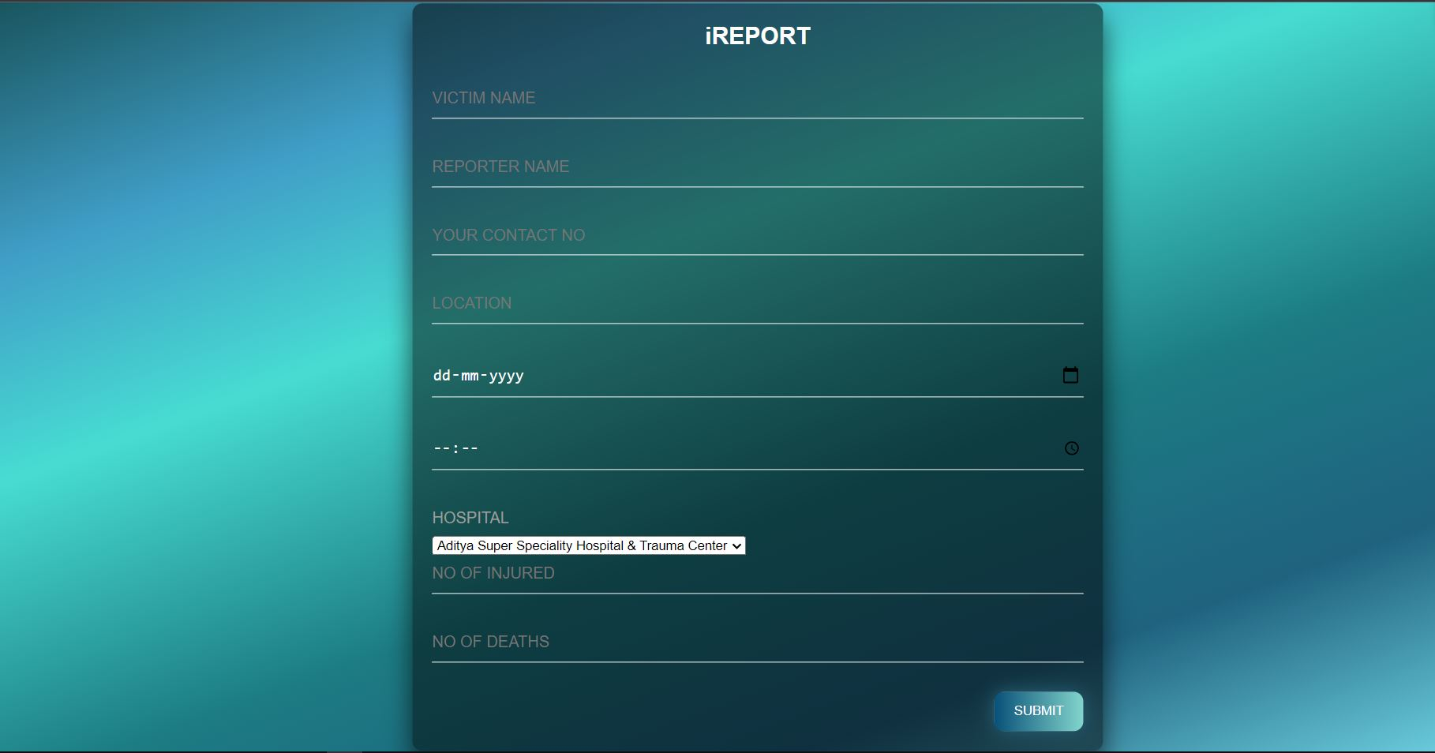

**User Dashboard-**

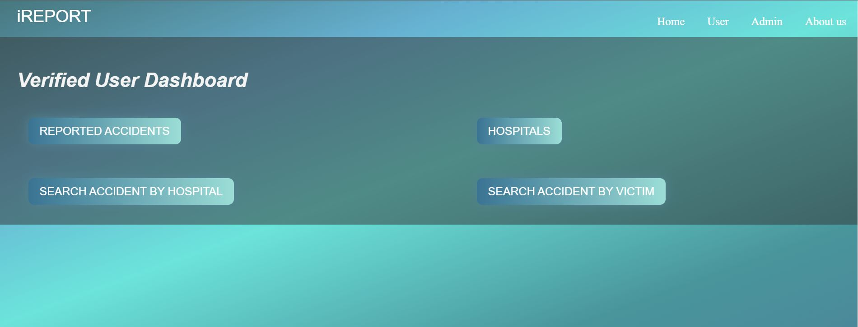

**User Home page-**

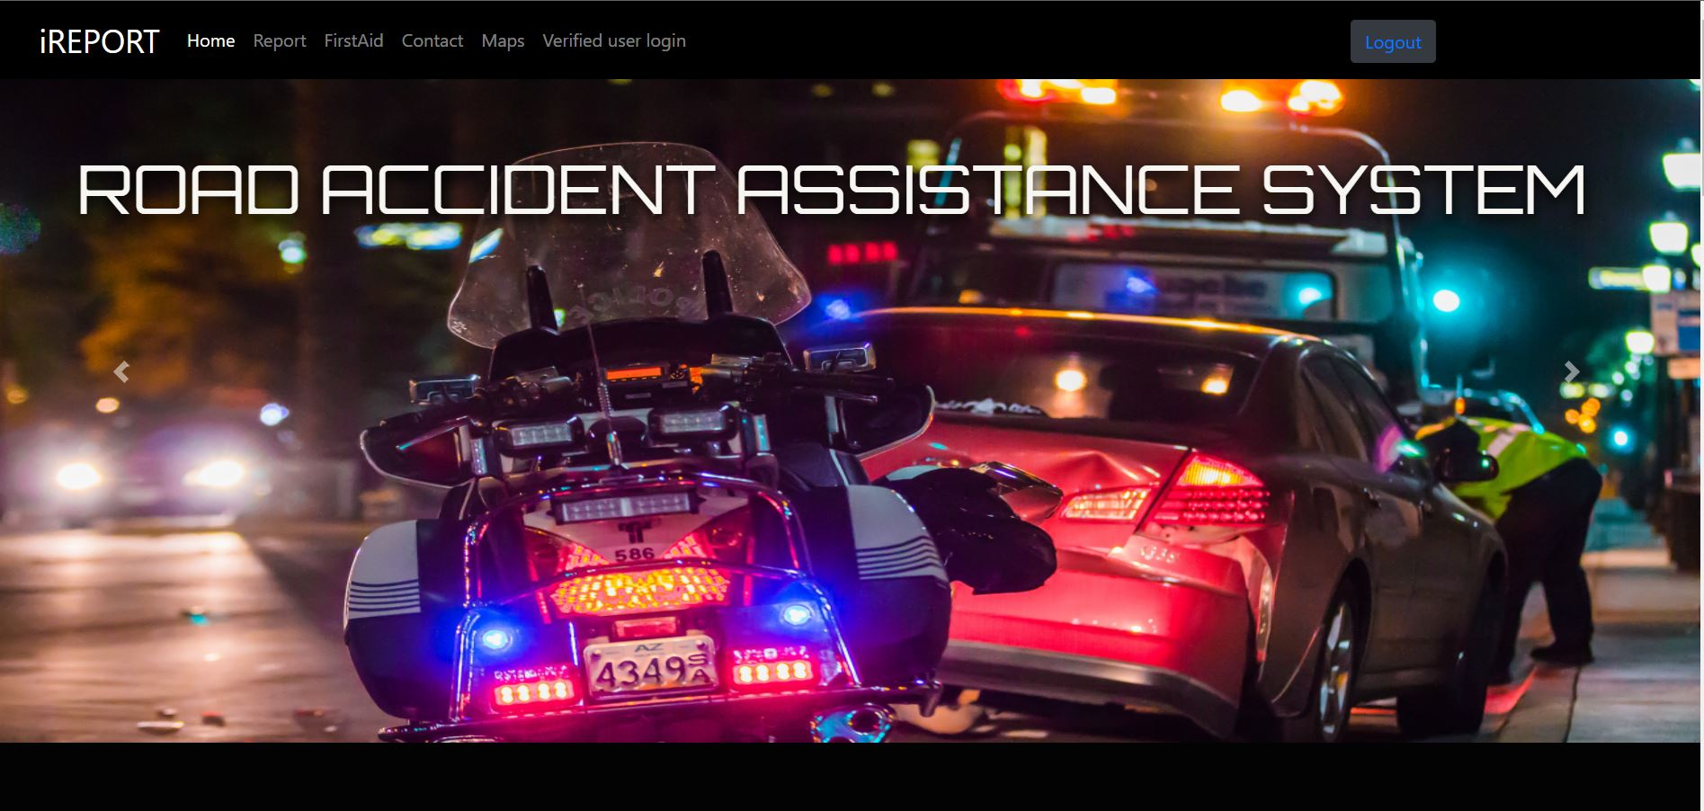

**Map-**

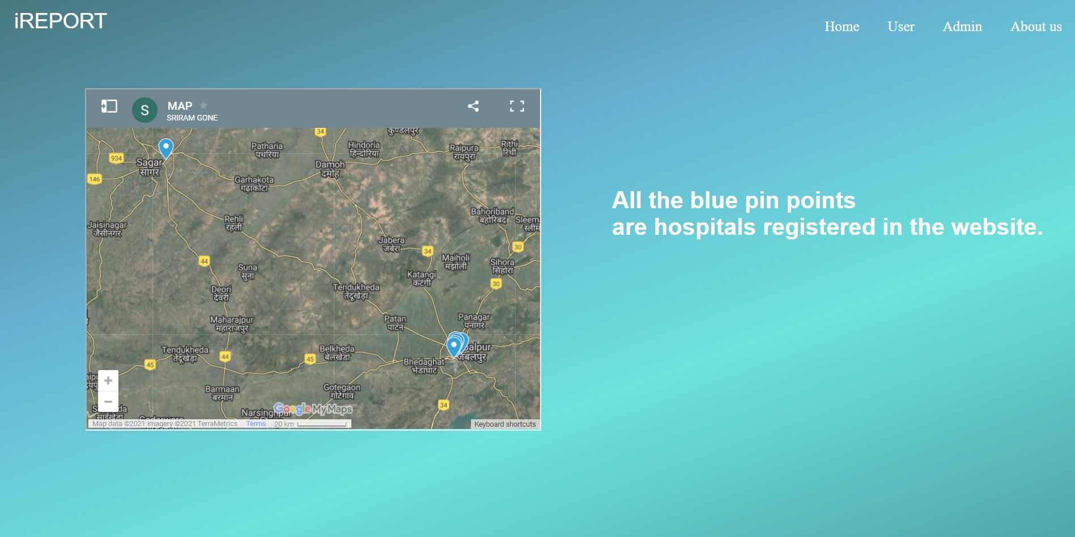

**First Aid page**- 